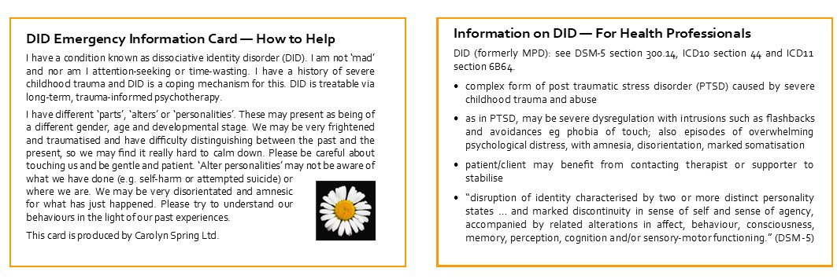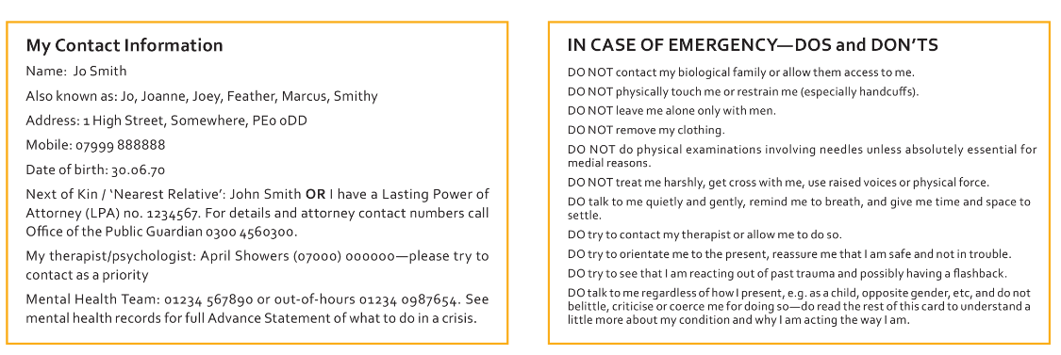

Create your own cards here

My Contact Information  Name Click or tap here to enter text.  Also known as Click or tap here to enter text.  Address Click or tap here to enter text.  Mobile Number Click or tap here to enter text.  Date of Birth Click or tap here to enter text.  Next of kin/Nearest relative Click or tap here to enter text.  Therapists contact Click or tap here to enter text.  Mental Health Team Click or tap here to enter text. |  | IN CASE OF EMERGENCYꟷDOS and DON’TS  DO NOT Click or tap here to enter text.  DO NOT Click or tap here to enter text.  DO NOT Click or tap here to enter text.  DO NOT Click or tap here to enter text.  DO Click or tap here to enter text.  DO Click or tap here to enter text.  DO Click or tap here to enter text.  DO Click or tap here to enter text.  DO Click or tap here to enter text.

